Department of Computer Science &Engineering
B.Tech III Semester
Academic Year 2026-2027
Database Management Systems(2501IT05)
Capstone Project Documentation


ADITYA UNIVERSITY
Surampalem, Kakinada District
Andhra Pradesh-533437


SCHOOL OF COMPUTING

Department of Computer Science and Engineering

CERTIFICATE

This is to certify that the Cornerstone project work entitled
“VEHICAL RENTAL MANAGEMENT SYSTEM” is submitted by

K. ABHIRAM CHANDU-25B11CS455
K.SAI SAMPATH -25B11CS364
K.SURYA PUSHKAR -25B11CS458
K.J V AVINASH -25B11CS404

in partial fulfillment of the requirements for the award of the B.Tech. degree in Computer Science and Engineering for the academic year 2026-2027.

Project Guide Head of the Department
Mrs. K Vydehi, M.Tech.,(Ph.D), Dr. Phani Sridhar , Ph.D,
Assistant Professor, Assistant Professor,
Department of CSE Department of CSE

DECLARATION

We hereby declare that the Cornerstone project entitled “VEHICAL RENTAL MANAGEMENT SYSTEM” is original and is submitted to ADITYA UNIVERSITY, Surampalem, in partial fulfillment of the requirements for the award of the B.Tech. Degree in Computer Science and Engineering. We further declare that this project work has not been submitted, either in full or in part, for the award of any degree in this or any other institution. We also confirm that this work complies with the Institutional Academic Integrity and AI Usage Policy

Place
Date:

BY
K. ABHIRAM CHANDU- 25B11CS455
K.SAI SAMPATH -25B11CS404
K.SURYA PUSHKAR- 25B11CS458
K.J V AVINASH -25B11CS364

ACKNOWLEDGEMENT

It is with immense pleasure that we express our sincere gratitude to our Cornerstone Project Guide, Mrs. K Vydehi, Assistant Professor, who has guided us throughout the project. Her valuable support, encouragement, and guidance have greatly contributed to the successful completion of this work.
We would like to thank our Deputy Heads of the Department, Dr. Chandra Sekhar Kolli, Associate Professor, Dr Hari Jyothula, Associate Professor and Dr Pennada Siva Satya Prasad, Assistant Profeesor, Department of Computer Science and Engineering, for their support and valuable suggestions.
Our deepest thanks to our Head of the Department Dr. Phani Sridhar Addepalli, Assistant Professor, for his inspiration and for providing all the necessary facilities and resources required for this project.
We also extend our sincere thanks to Dr. M.V. Rajesh, Associate Dean, School of Computing for their encouragement and support during the course of our project.
We would like to express our sincere gratitude to Dr.G.Suresh,Registrar Dr. A Ramesh, Pro Vice-Chancellor (Engineering & Sciences), Dr.S.RamaSree,Pro Vice-Chancellor (Academics), Dr. M.B. Srinivas, Vice-Chancellor, Dr. M. Sreenivasa Reddy, Deputy Pro Chancellor and Management, Aditya University for providing excellent infrastructure and state-of-the-art laboratories.
Finally, we would like to thank the faculty members, lab technicians, non-teaching staff, and our friends who have directly or indirectly supported us in completing this Cornerstone project successfully.

TABLE OF CONTENTS
S.No | Contents | Page No.
 | Cover Page | –
 | Certificate | –
 | Declaration | –
 | Acknowledgement | –
 | Table of Contents | 1
 | Abstract | 2
 | List of Figures | 3
 | List of Tables | 4
 | Acronyms | 5
1 | Introduction | 6-8
2 | System Analysis | 8-10
3 | Database Design | 11
4 | ER Diagram | 12
5 | Relational Schema | 13
6 | Table Design | 14-17
7 | Normalization | 18-21
8 | SQL Implementation | 22-28
9 | SQL Queries & Screenshots | 29-40
10 | Conclusion | 41
11 | Future Enhancements | 42
 | References | 43

ABSTRACT
The Vehicle Rental Management System is a database application designed to manage vehicle rental activities in a systematic and efficient manner. The system stores and manages information related to customers, vehicles, employees, and bookings through a centralized relational database. It helps maintain customer details, vehicle information, employee records, and booking transactions.The database reduces data redundancy and maintains data integrity using primary keys, foreign keys, unique constraints, NOT NULL constraints, and appropriate validation rules. The system supports efficient storage, retrieval, updating, and management of vehicle rental information using SQL queries.The database is normalized up to Third Normal Form (3NF) to reduce redundancy and avoid insertion, deletion, and update anomalies. The proposed system provides a structured foundation for customer management, vehicle management, employee management, booking management, and rental-related reporting.

LIST OF FIGURES
Figure | Name | Pg.No
1 | ER Diagram of Vehicle Rental Management System | 12
2 | Proposed Database Application Architecture | 11
3 | Customer Management Table / Screen | 29
4 | . Vehicle Management Table / Screen | 29
5 | Employee Management Table / Screen | 30
6 | Booking Management Table / Screen | 30
7 | SQL Query Output Screenshots | 29-40

LIST OF TABLES
S.No | Name | Pg.No
1 | Functional Requirements | 9
2 | Major Database Entities | 11
3 | Relationships | 11
4 | Relational Schema | 13
5 | Customer Table Structure | 14
6 | Vehicle Table Structure | 14
7 | Staff Table Structure | 15
8 | Booking Table Structure | 15-16
9 | Payment Table Structure | 16-17
10 | Returns Table Structure | 17
11 | Keys and Constraints | 17-18
12 | 1NF Booking and Payment Table | 20
13 | Reason for Separation of Tables | 22
14 | Sample Data Records | 26-28

ACRONYMS
- DBMS – Database Management System
- ER – Entity Relationship
- SQL – Structured Query Language
- DDL – Data Definition Language
- DML – Data Manipulation Language
- DQL – Data Query Language
- DCL – Data Control Language
- TCL – Transaction Control Language
- PK – Primary Key
- FK – Foreign Key
- 1NF – First Normal Form
- 2NF – Second Normal Form
- 3NF – Third Normal Form
1. INTRODUCTION
1.1 Brief Information about the Project
The Vehicle Rental Management System is a database application used to manage the activities involved in renting vehicles to customers. The system provides a centralized relational database for storing customer information, vehicle details, employee information, and booking records.
The system is designed to replace manual records and disconnected data files with a structured database. It allows rental information to be stored consistently and retrieved efficiently using SQL queries.
The database maintains relationships between customers, vehicles, employees, and bookings. Primary keys uniquely identify records, while foreign keys maintain relationships between related tables.
1.2 Motivation and Contribution of Project
The project is motivated by common problems in manual vehicle rental management such as duplicate records, difficulty in searching information, inconsistent data, and time-consuming booking management.
A centralized database provides a systematic way of managing rental information and maintaining relationships between different entities.
The major contributions of the project are:
• Centralizing customer, vehicle, employee, and booking information.
• Reducing duplicate and inconsistent data.
• Maintaining relationships using primary and foreign keys.
• Managing vehicle availability information.
• Maintaining customer booking records.
• Supporting efficient SQL queries and reports.
• Reducing manual effort in rental record management.
• Providing a structured database for future expansion.
1.3 Objectives of the Project
The main objectives of the Vehicle Rental Management System are:
• To develop a centralized vehicle rental database.
• To maintain customer information.
• To store and manage vehicle details.
• To maintain employee information.
• To manage vehicle booking records.
• To maintain vehicle availability status.
• To reduce data redundancy and update anomalies.
• To maintain referential integrity using primary and foreign keys.
• To support efficient SQL queries for retrieving rental information.
• To provide a structured database for vehicle rental operations.
1.4 Scope of the Project
The scope of the project covers the database-oriented management of vehicle rental information.
The core scope includes:
• Customer information management.
• Vehicle information management.
• Employee information management.
• Vehicle booking management.
• Vehicle availability management.
• Retrieval of customer and booking information.
• Retrieval of vehicle and rental information.
• SQL-based reporting and data analysis.
The database can be extended in the future with additional features such as payment management, maintenance management, insurance management, branch management, online booking, and web/mobile interfaces if required.

2. SYSTEM ANALYSIS
2.1 Existing System
The existing manual vehicle rental system may involve maintaining rental information using paper records, spreadsheets, or separate files.
The major limitations of the existing system are:
• Manual record maintenance.
• Multiple Excel sheets or disconnected files.
• Duplicate customer and vehicle information.
• Difficulty in searching booking records.
• Difficulty in checking vehicle availability.
• Time-consuming record updates.
• Higher possibility of data-entry errors.
• Difficulty in generating consolidated reports.
• Greater possibility of inconsistent information.
2.2 Proposed System
The proposed Vehicle Rental Management System uses a centralized relational database to manage rental information.
The system organizes customer, vehicle, employee, and booking information into related tables. Primary keys and foreign keys are used to maintain relationships and referential integrity.

The proposed system provides:
• Centralized database management.
• Customer management.
• Vehicle management.
• Employee management.
• Booking management.
• Vehicle availability management.
• SQL-based searching and reporting.
• Referential integrity.
• Reduced data redundancy.
• Efficient data retrieval.
2.3 Functional Requirements
Module Functional Requirement
Customer Management Add, update, search, and display customer details.
Vehicle Management Add, update, search, and display vehicle details.
Employee Management Store and maintain employee information.
Booking Management Create, update, search, and display vehicle booking details.
Vehicle Availability Maintain and display the availability status of vehicles.
Search and Reporting Retrieve customer, vehicle, employee, and booking information using SQL queries.
Data Management Insert, update, delete, and retrieve records from the database.
2.4 Non-Functional Requirements
• Performance – Queries should return results efficiently for normal rental management operations.
• Integrity – Invalid references and duplicate key values should be prevented.
• Security – Database access should be controlled for authorized users.
• Usability – Database tables and reports should be understandable and easy to use.
• Reliability – Transactions should maintain a consistent database state.
• Scalability – The database should support an increasing number of customers, vehicles, employees, and bookings.
• Maintainability – The database structure should be easy to maintain and update.

2.5 Requirements Specification
Hardware Requirements:
• Intel i3 processor or above.
• Minimum 4 GB RAM.
• Adequate storage space.
• Standard monitor.
• Keyboard and mouse.
Software Requirements:
• Windows 10/11 or equivalent operating system.
• Oracle Database or other relational DBMS used for implementation.
• SQL development environment.
• Computer system with database connectivity.

3. DATABASE DESIGN
3.1 Major Entities
Entity Description
Customer Stores customer information.
Vehicle Stores vehicle details and availability information.
Employee Stores employee information.
Booking Represents vehicle rental booking transactions.
3.2 ER Model
The ER model represents the major entities and their relationships in the Vehicle Rental Management System.
The main entities are Customer, Vehicle, Employee, and Booking.
The Customer entity stores customer-related information. The Vehicle entity stores information about vehicles available for rental. The Employee entity stores employee information. The Booking entity records rental bookings made by customers for vehicles.
The Booking entity connects customers and vehicles through booking transactions.
3.3 Relationships
Relationship Description
Customer → Booking One customer can have many bookings.
Vehicle → Booking One vehicle can be associated with many bookings over time.
Employee → Booking An employee can manage multiple booking records.
Customer → Vehicle Customers obtain vehicles through booking transactions.
Vehicle → Customer A vehicle can be rented by different customers through different bookings over time.

4. ER DIAGRAM
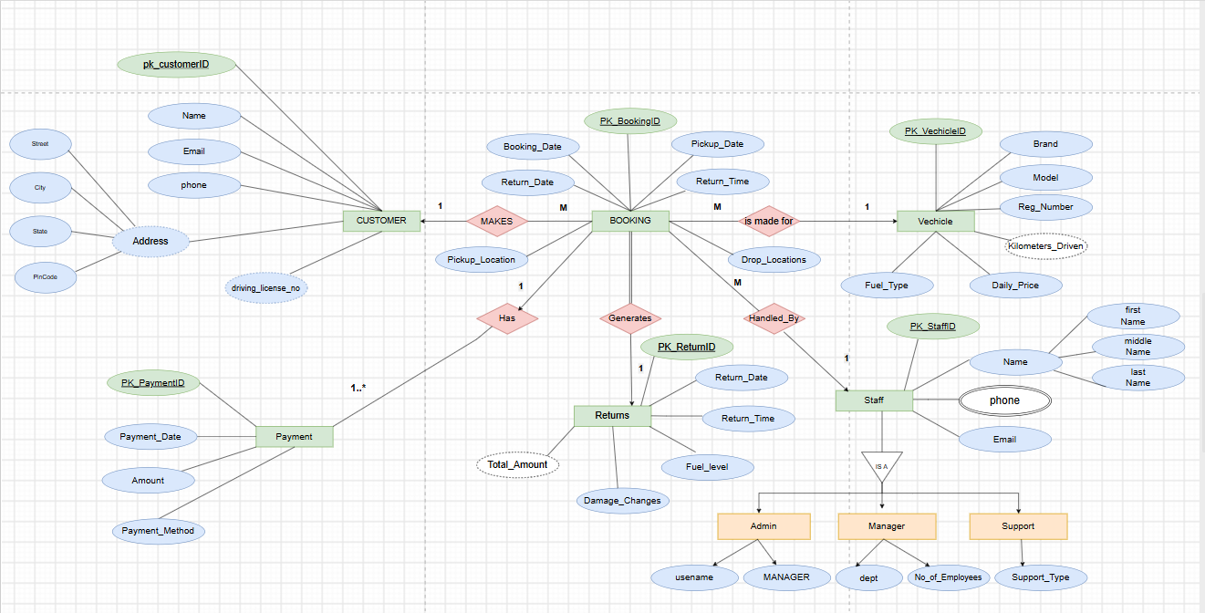
Figure 1: ER Diagram of University Academic Management Databas
The ER diagram summarizes the entity structure and cardinalities described in the supplied DBMS project material. It is a documentation-level representation; the final project team should align attribute names and cardinalities with the actual implemented database.

5. RELATIONAL SCHEMA
Relation | Relational Schema
CUSTOMER | Customer_Id (Pk), Name, Phone, Email, Address
VEHICLE | Vehicle_Id (Pk), Vehicle_Number (Unique), Vehicle_Type, Brand, Model, Rental_Rate, Availability_Status
EMPLOYEE | Employee_Id (Pk), Name, Phone, Role, Salary
BOOKING | Booking_Id, Customer_Id, Vehicle_Id, Staff_Id, Booking_Date, Return_Date, Pickup_Date, Return_Time, Pickup_Location, Drop_Locations
PAYMENT | Payment_Id, Booking_Id, Payment_Date, Amount, Payment_Method
RETURNS | Return_Id, Booking_Id, Return_Date, Return_Time, Fuel_Level, Damage_Changes, Total_Amount

The relational schema follows the structure presented in the supplied project material. The Student and Faculty relations reference Department; Course references Department and Faculty; Enrollment references Student and Course; and Result references Enrollment.

6. TABLE DESIGN
6.1 Customer Table
Attribute | Data Type | Constraint | Description
Customer_ID | NUMBER | PK, NOT NULL | Unique customer identifier
Customer_Name | VARCHAR2(100) | NOT NULL | Customer name
Phone | VARCHAR2(15) | UNIQUE | Customer contact number
Email | VARCHAR2(100) | UNIQUE | Customer email address
Address | VARCHAR2(200) | — | Customer address

6.2 Vehicle Table
Attribute | Data Type | Constraint | Description
Vehicle_ID | NUMBER | PK, NOT NULL | Unique vehicle identifier
Vehicle_Number | VARCHAR2(20) | UNIQUE, NOT NULL | Vehicle registration number
Vehicle_Type | VARCHAR2(50) | NOT NULL | Type of vehicle
Brand | VARCHAR2(50) | — | Vehicle brand
Model | VARCHAR2(50) | — | Vehicle model
Rental_Rate | NUMBER(10,2) | CHECK | Rental charge per day
Availability_Status | VARCHAR2(20) | NOT NULL | Current vehicle availability

6.3 Staff Table
Attribute | Data Type | Constraint | Description
Staff_ID | NUMBER | PK, NOT NULL | Unique staff identifier
Staff_Name | VARCHAR2(100) | NOT NULL | Staff name
Phone | VARCHAR2(15) | UNIQUE | Staff contact number
Role | VARCHAR2(50) | NOT NULL | Staff role
Salary | NUMBER(10,2) | CHECK | Staff salary
6.4 Booking Table
Attribute | Data Type | Constraint | Description
Booking_ID | NUMBER | PK, NOT NULL | Unique booking identifier
Customer_ID | NUMBER | FK, NOT NULL | References Customer
Vehicle_ID | NUMBER | FK, NOT NULL | References Vehicle
Staff_ID | NUMBER | FK, NOT NULL | References Staff
Booking_Date | DATE | NOT NULL | Date of booking
Pickup_Date | DATE | NOT NULL | Vehicle pickup date
Return_Date | DATE | NOT NULL | Expected vehicle return date
Return_Time | VARCHAR2(10) | — | Expected return time
Pickup_Location | VARCHAR2(100) | — | Vehicle pickup location
Drop_Location | VARCHAR2(100) | — | Vehicle drop location

6.5 Payment Table
Attribute | Data Type | Constraint | Description
Payment_ID | NUMBER | PK, NOT NULL | Unique payment identifier
Booking_ID | NUMBER | FK, NOT NULL | References Booking
Payment_Date | DATE | NOT NULL | Date of payment
Amount | NUMBER(10,2) | NOT NULL | Payment amount
Payment_Method | VARCHAR2(30) | NOT NULL | Mode of payment

6.6 Returns Table
Attribute | Data Type | Constraint | Description
Return_ID | NUMBER | PK, NOT NULL | Unique return identifier
Booking_ID | NUMBER | FK, NOT NULL | References Booking
Return_Date | DATE | NOT NULL | Actual vehicle return date
Return_Time | VARCHAR2(10) | — | Actual return time
Fuel_Level | VARCHAR2(20) | — | Fuel level at return
Damage_Charges | NUMBER(10,2) | DEFAULT 0 | Charges for vehicle damage
Total_Amount | NUMBER(10,2) | — | Final rental amount

6.7 Keys and Constraints
Constraint | Type | Applied To / Purpose
Primary Key | PK | Customer_ID, Vehicle_ID, Staff_ID, Booking_ID, Payment_ID, Return_ID
Foreign Key | FK | Booking.Customer_ID, Booking.Vehicle_ID, Booking.Staff_ID, Payment.Booking_ID, Returns.Booking_ID
NOT NULL | Required | Important identifiers, names and transaction details
UNIQUE | Unique | Vehicle_Number, Customer Phone, Customer Email and Staff Phone
CHECK | Validation | Rental_Rate, Salary, Amount and Damage_Charges
DEFAULT | Default Value | Damage_Charges can be set to 0

6.8 Relationship References
Booking.Customer_ID → Customer(Customer_ID)
Booking.Vehicle_ID → Vehicle(Vehicle_ID)
Booking.Staff_ID → Staff(Staff_ID)
Payment.Booking_ID → Booking(Booking_ID)
Returns.Booking_ID → Booking(Booking_ID)

7. NORMALIZATION
Normalization is the process of organizing data into related tables to reduce data redundancy and avoid insertion, deletion, and update anomalies. The Vehicle Rental Management System is normalized up to Third Normal Form (3NF).
For this project, the normalization process is demonstrated using a combined relation containing customer, booking and vehicle information. The normalization process is performed step-by-step from the original relation to 1NF, 2NF and finally 3NF.
7.1 Unnormalized Form (UNF)
In the unnormalized form, customer, booking and vehicle details may be stored together in a single relation.
The original relation can be represented as:
FIRST(Customer_ID, Booking_ID, Customer_Name, Booking_Date, Start_Date, End_Date, Vehicle_ID, Vehicle_Number, Vehicle_Type, Brand, Model)
The functional dependencies are:
Booking_ID → Customer_ID, Booking_Date, Start_Date, End_Date, Vehicle_ID
Customer_ID → Customer_Name
Vehicle_ID → Vehicle_Number, Vehicle_Type, Brand, Model
In the unnormalized structure, customer and vehicle information may be repeated for different booking records.
Problems in UNF:
- Customer information may be repeated.
- Vehicle information may be repeated.
- Data redundancy is high.
- Update anomalies may occur.
- Insertion anomalies may occur.
- Deletion anomalies may occur.
- Maintaining repeated customer and vehicle information is difficult.
7.2 First Normal Form (1NF)
In 1NF, all attributes must contain atomic values and repeating or multivalued groups must be removed.
For this project, the original relation is divided into two relations as required for the normalization process.
CUSTOMER_BOOKING_1NF
CUSTOMER_BOOKING_1NF(Customer_ID, Booking_ID, Customer_Name, Booking_Date, Start_Date, End_Date)
Primary Key: (Customer_ID, Booking_ID)
Functional Dependency:
(Customer_ID, Booking_ID) → Customer_Name, Booking_Date, Start_Date, End_Date
BOOKING_VEHICLE_1NF
BOOKING_VEHICLE_1NF(Booking_ID, Vehicle_ID, Vehicle_Number, Vehicle_Type, Brand, Model)
Primary Key: (Booking_ID, Vehicle_ID)
Functional Dependency:
(Booking_ID, Vehicle_ID) → Vehicle_Number, Vehicle_Type, Brand, Model
In these relations, every attribute contains a single atomic value. There are no repeating groups or multiple values in a single field.
Result of 1NF
- All attributes contain atomic values.
- Repeating groups are removed.
- Each row represents a single record.
- Primary keys are defined for the relations.
- Customer and booking information are separated from booking and vehicle information.
Therefore, the relations satisfy the requirements of First Normal Form (1NF).

7.3 Second Normal Form (2NF)
In 2NF, the relation must first satisfy 1NF. Then partial dependencies are removed.
In the 1NF relations, customer information depends on Customer_ID, while booking information depends on Booking_ID. Therefore, customer details should be stored separately from booking details.
The relations are separated as follows.
CUSTOMER_2NF
CUSTOMER_2NF(Customer_ID, Customer_Name)
Primary Key: Customer_ID
Functional Dependency:
Customer_ID → Customer_Name
BOOKING_2NF
BOOKING_2NF(Booking_ID, Customer_ID, Booking_Date, Start_Date, End_Date, Vehicle_ID, Vehicle_Number, Vehicle_Type, Brand, Model)
Primary Key: Booking_ID
Functional Dependency:
Booking_ID → Customer_ID, Booking_Date, Start_Date, End_Date, Vehicle_ID
The customer details are separated into the CUSTOMER_2NF relation. The booking details are stored in the BOOKING_2NF relation.
This removes the partial dependency related to customer information and reduces data redundancy.
Result of 2NF
- The relations satisfy 1NF.
- Customer details are separated from booking details.
- Partial dependency is removed.
- Data redundancy is reduced.
- Customer information does not need to be repeated for every booking.
Therefore, the resulting structure satisfies Second Normal Form (2NF).
7.4 Third Normal Form (3NF)
In 3NF, the relation must satisfy 2NF and transitive dependencies must be removed.
In the BOOKING_2NF relation, the following dependencies exist:
Booking_ID → Vehicle_ID
Vehicle_ID → Vehicle_Number, Vehicle_Type, Brand, Model
Therefore:
Booking_ID → Vehicle_Number, Vehicle_Type, Brand, Model
This represents a transitive dependency, because the vehicle details depend on Vehicle_ID, rather than directly on the primary key Booking_ID.
Therefore, the vehicle details are separated into a separate relation.
7.5 Final 3NF Structure
CUSTOMER_2NF
CUSTOMER_2NF(Customer_ID, Customer_Name)
Primary Key: Customer_ID
BOOKING_DETAILS_3NF
BOOKING_DETAILS_3NF(Booking_ID, Customer_ID, Booking_Date, Start_Date, End_Date, Vehicle_ID)
Primary Key: Booking_ID
Foreign Key: Customer_ID references CUSTOMER_2NF(Customer_ID)
Foreign Key: Vehicle_ID references VEHICLE_DETAILS_3NF(Vehicle_ID)
Functional Dependency:
Booking_ID → Customer_ID, Booking_Date, Start_Date, End_Date, Vehicle_ID
VEHICLE_DETAILS_3NF
VEHICLE_DETAILS_3NF(Vehicle_ID, Vehicle_Number, Vehicle_Type, Brand, Model)
Primary Key: Vehicle_ID
Functional Dependency:
Vehicle_ID → Vehicle_Number, Vehicle_Type, Brand, Model
The vehicle information is now stored separately from the booking information. Therefore, the transitive dependency is removed.
Result of 3NF
- The relations satisfy 2NF.
- Transitive dependency is removed.
- Vehicle information is stored separately.
- Data redundancy is reduced.
- Update anomalies are reduced.
- Insertion and deletion anomalies are minimized.
- Each non-key attribute depends directly on the primary key of its relation.
Therefore, the resulting relations satisfy Third Normal Form (3NF).
7.6 Reason for Separation
Relation | Reason for Separation
CUSTOMER_2NF | Stores customer details separately
BOOKING_DETAILS_3NF | Stores booking details and references the customer and vehicle
VEHICLE_DETAILS_3NF | Stores vehicle details separately
BOOKING_VEHICLE_1NF | Separates booking and vehicle information during the 1NF stage
CUSTOMER_BOOKING_1NF | Separates customer and booking information during the 1NF stage

Final Normalization Flow
UNF
FIRST
↓
1NF
CUSTOMER_BOOKING_1NF
BOOKING_VEHICLE_1NF
↓
2NF
CUSTOMER_2NF
BOOKING_2NF
↓
3NF
CUSTOMER_2NF
BOOKING_DETAILS_3NF
VEHICLE_DETAILS_3NF
This normalization process reduces redundancy and removes partial and transitive dependencies from the selected relation.

8. SQL IMPLEMENTATION

8.1 DDL – Data Definition Language

CUSTOMER Table:
CREATE TABLE CUSTOMER (
Customer_ID NUMBER PRIMARY KEY,
Customer_Name VARCHAR2(100) NOT NULL,
Phone VARCHAR2(15) UNIQUE,
Email VARCHAR2(100) UNIQUE,
Address VARCHAR2(200)
);
VEHICLE Table:
CREATE TABLE VEHICLE (
Vehicle_ID NUMBER PRIMARY KEY,
Vehicle_Number VARCHAR2(20) UNIQUE NOT NULL,
Vehicle_Type VARCHAR2(50) NOT NULL,
Brand VARCHAR2(50),
Model VARCHAR2(50),
Rental_Rate NUMBER(10,2) CHECK (Rental_Rate > 0),
Availability_Status VARCHAR2(20) NOT NULL
);
STAFF Table
CREATE TABLE STAFF (
Staff_ID NUMBER PRIMARY KEY,
Staff_Name VARCHAR2(100) NOT NULL,
Phone VARCHAR2(15) UNIQUE,
Role VARCHAR2(50) NOT NULL,
Salary NUMBER(10,2) CHECK (Salary > 0)
);

BOOKING Table
CREATE TABLE BOOKING (
Booking_ID NUMBER PRIMARY KEY,
Customer_ID NUMBER NOT NULL,
Vehicle_ID NUMBER NOT NULL,
Staff_ID NUMBER NOT NULL,
Booking_Date DATE NOT NULL,
Pickup_Date DATE NOT NULL,
Return_Date DATE NOT NULL,
Return_Time VARCHAR2(10),
Pickup_Location VARCHAR2(100),
Drop_Location VARCHAR2(100),
CONSTRAINT FK_BOOKING_CUSTOMER
FOREIGN KEY (Customer_ID)
REFERENCES CUSTOMER(Customer_ID),
CONSTRAINT FK_BOOKING_VEHICLE
FOREIGN KEY (Vehicle_ID)
REFERENCES VEHICLE(Vehicle_ID),
CONSTRAINT FK_BOOKING_STAFF
FOREIGN KEY (Staff_ID)
REFERENCES STAFF(Staff_ID)
);

PAYMENT Table
CREATE TABLE PAYMENT (
Payment_ID NUMBER PRIMARY KEY,
Booking_ID NUMBER NOT NULL,
Payment_Date DATE NOT NULL,
Amount NUMBER(10,2) NOT NULL,
Payment_Method VARCHAR2(30) NOT NULL,
CONSTRAINT FK_PAYMENT_BOOKING
FOREIGN KEY (Booking_ID)
REFERENCES BOOKING(Booking_ID)
);
RETURNS Table
CREATE TABLE RETURNS (
Return_ID NUMBER PRIMARY KEY,
Booking_ID NUMBER NOT NULL,
Return_Date DATE NOT NULL,
Return_Time VARCHAR2(10),
Fuel_Level VARCHAR2(20),
Damage_Charges NUMBER(10,2) DEFAULT 0,
Total_Amount NUMBER(10,2),

CONSTRAINT FK_RETURNS_BOOKING
FOREIGN KEY (Booking_ID)
REFERENCES BOOKING(Booking_ID)
);

8.2 DML – Data Manipulation Language
INSERT INTO CUSTOMER VALUES
(1, 'Rahul Kumar', '9876543210', 'rahul@gmail.com', 'Rajahmundry');
INSERT INTO CUSTOMER VALUES
(2, 'Priya Sharma', '9876543211', 'priya@gmail.com', 'Kakinada');
INSERT INTO CUSTOMER VALUES
(3, 'Arjun Kumar', '9876543212', 'arjun@gmail.com', 'Visakhapatnam');
INSERT INTO CUSTOMER VALUES
(4, 'Sneha Reddy', '9876543213', 'sneha@gmail.com', 'Vijayawada');
INSERT INTO CUSTOMER VALUES
(5, 'Kiran Rao', '9876543214', 'kiran@gmail.com', 'Hyderabad');
INSERT INTO VEHICLE VALUES
(201, 'AP05AB1234', 'Car', 'Hyundai', 'Creta', 2500, 'Available');
INSERT INTO VEHICLE VALUES
(202, 'AP05CD5678', 'Car', 'Tata', 'Nexon', 2200, 'Rented');
INSERT INTO VEHICLE VALUES
(203, 'AP05EF9012', 'Bike', 'Honda', 'Activa', 800, 'Available');
INSERT INTO VEHICLE VALUES
(204, 'AP05GH3456', 'Car', 'Maruti', 'Swift', 2000, 'Available');
INSERT INTO VEHICLE VALUES
(205, 'AP05IJ7890', 'Bike', 'Royal Enfield', 'Classic 350', 1200, 'Maintenance');

INSERT INTO STAFF VALUES

(301, 'Ramesh Kumar', '9988776655', 'Manager', 35000);

INSERT INTO STAFF VALUES

(302, 'Suresh Rao', '9988776656', 'Booking Executive', 28000);

INSERT INTO STAFF VALUES

(303, 'Anil Kumar', '9988776657', 'Receptionist', 25000);

INSERT INTO STAFF VALUES

(304, 'Vijay Sharma', '9988776658', 'Manager', 38000);

INSERT INTO STAFF VALUES

(305, 'Manoj Reddy', '9988776659', 'Booking Executive', 27000);

INSERT INTO BOOKING VALUES
(101, 1, 201, 301,
TO_DATE('10-09-2026','DD-MM-YYYY'),
TO_DATE('11-09-2026','DD-MM-YYYY'),
TO_DATE('13-09-2026','DD-MM-YYYY'),
'06:00 PM', 'Rajahmundry', 'Rajahmundry');

INSERT INTO BOOKING VALUES
(102, 2, 202, 302,
TO_DATE('11-09-2026','DD-MM-YYYY'),
TO_DATE('12-09-2026','DD-MM-YYYY'),
TO_DATE('15-09-2026','DD-MM-YYYY'),
'05:00 PM', 'Kakinada', 'Kakinada');

INSERT INTO BOOKING VALUES
(103, 3, 203, 301,
TO_DATE('12-09-2026','DD-MM-YYYY'),
TO_DATE('13-09-2026','DD-MM-YYYY'),
TO_DATE('14-09-2026','DD-MM-YYYY'),
'04:00 PM', 'Visakhapatnam', 'Visakhapatnam');

INSERT INTO BOOKING VALUES
(104, 4, 204, 303,
TO_DATE('13-09-2026','DD-MM-YYYY'),
TO_DATE('14-09-2026','DD-MM-YYYY'),
TO_DATE('17-09-2026','DD-MM-YYYY'),
'06:30 PM', 'Vijayawada', 'Vijayawada');

INSERT INTO BOOKING VALUES
(105, 5, 205, 304,
TO_DATE('14-09-2026','DD-MM-YYYY'),
TO_DATE('15-09-2026','DD-MM-YYYY'),
TO_DATE('18-09-2026','DD-MM-YYYY'),
'05:30 PM', 'Hyderabad', 'Hyderabad');

INSERT INTO PAYMENT VALUES
(501, 101, TO_DATE('10-09-2026','DD-MM-YYYY'), 7500, 'UPI');
INSERT INTO PAYMENT VALUES
(502, 102, TO_DATE('11-09-2026','DD-MM-YYYY'), 6600, 'Cash');
INSERT INTO PAYMENT VALUES
(503, 103, TO_DATE('12-09-2026','DD-MM-YYYY'), 1600, 'Card');
INSERT INTO PAYMENT VALUES
(504, 104, TO_DATE('13-09-2026','DD-MM-YYYY'), 6000, 'UPI');
INSERT INTO PAYMENT VALUES
(505, 105, TO_DATE('14-09-2026','DD-MM-YYYY'), 4800, 'Card');

INSERT INTO RETURNS VALUES
(601, 101, TO_DATE('13-09-2026','DD-MM-YYYY'), '05:30 PM', 'Full', 0, 7500);
INSERT INTO RETURNS VALUES
(602, 102, TO_DATE('15-09-2026','DD-MM-YYYY'), '04:45 PM', 'Half', 500, 7100);
INSERT INTO RETURNS VALUES
(603, 103, TO_DATE('14-09-2026','DD-MM-YYYY'), '03:30 PM', 'Full', 0, 1600);
INSERT INTO RETURNS VALUES
(604, 104, TO_DATE('17-09-2026','DD-MM-YYYY'), '06:00 PM', 'Half', 300, 6300);

INSERT INTO RETURNS VALUES
(605, 105, TO_DATE('18-09-2026','DD-MM-YYYY'), '05:00 PM', 'Full', 0, 4800);

8.3 DQL – Data Query Language
SELECT * FROM CUSTOMER;
SELECT * FROM VEHICLE;
SELECT * FROM STAFF;
SELECT * FROM BOOKING;
SELECT * FROM BOOKING;
SELECT * FROM RETURNS;

9. SQL QUERIES & SCREENSHOTS
The following query set is prepared to satisfy the documentation requirement for a 30–40 query SQL section. The examples cover selection, filtering, joins, aggregation, subqueries, updates, deletion, and reporting. Exact outputs depend on the records inserted in the final project database.
9.1 Basic Queries
Q1. Display all customers
SELECT * FROM CUSTOMER;
Output:
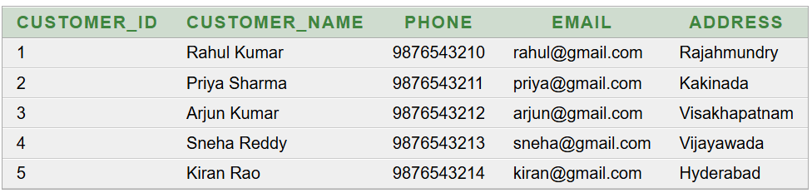
Q2. Display all vehicles
SELECT * FROM VEHICLE;
Output:
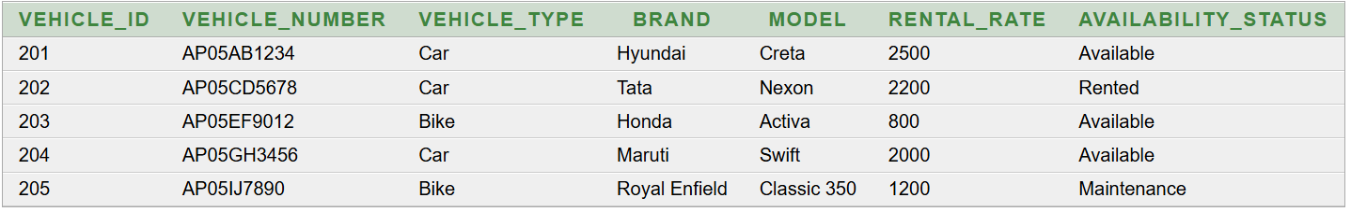
Q3. Display all staff
SELECT * FROM STAFF;
Output:
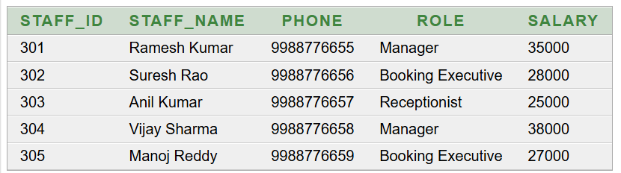

Q4. Display available vehicles
SELECT Vehicle_ID, Vehicle_Number, Vehicle_Type, Brand, Model
FROM VEHICLE
WHERE Availability_Status = 'Available';
Output:
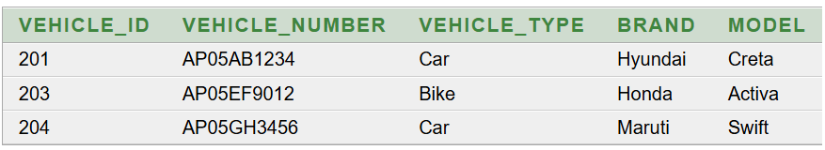
Q5. Display vehicles with rental rate greater than 2000
SELECT Vehicle_ID, Vehicle_Number, Brand, Model, Rental_Rate
FROM VEHICLE
WHERE Rental_Rate > 2000;
Output:
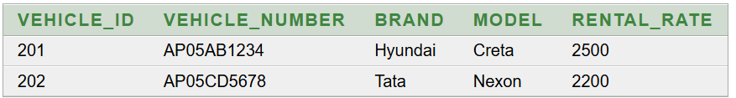
Q6. Display bookings in descending order of booking date
SELECT *
FROM BOOKING
ORDER BY Booking_Date DESC;
Output:
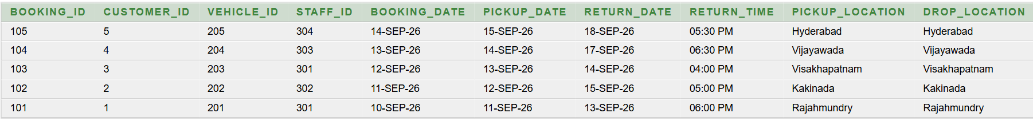
Q7. Display payment details
SELECT Payment_ID, Booking_ID, Payment_Date, Amount, Payment_Method
FROM PAYMENT;

Output:
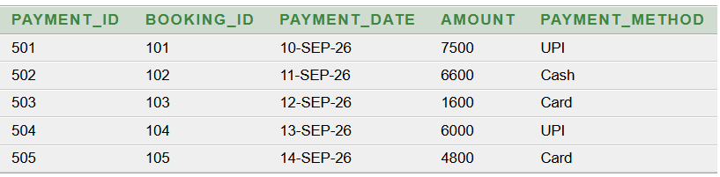
Q8. Display customer names with their booking details
SELECT c.Customer_Name,
b.Booking_ID,
b.Booking_Date,
b.Pickup_Date,
b.Return_Date
FROM CUSTOMER c
JOIN BOOKING b
ON c.Customer_ID = b.Customer_ID;
Output:
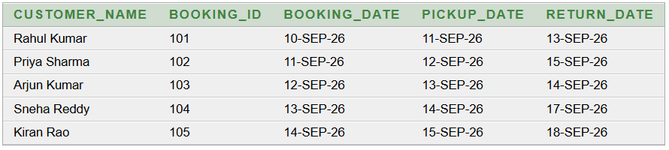
Q9. Display vehicle details for each booking
SELECT b.Booking_ID,
v.Vehicle_Number,
v.Vehicle_Type,
v.Brand,
v.Model
FROM BOOKING b
JOIN VEHICLE v
ON b.Vehicle_ID = v.Vehicle_ID;
Output:
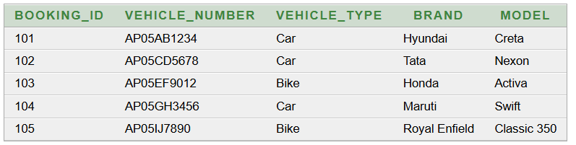
Q10. Display booking details with staff information
SELECT b.Booking_ID,
s.Staff_Name,
s.Role,
b.Booking_Date,
b.Pickup_Date
FROM BOOKING b
JOIN STAFF s
ON b.Staff_ID = s.Staff_ID;
Output:
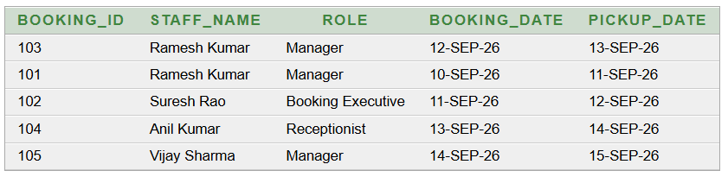
Q11. Display complete booking, customer and vehicle details
SELECT b.Booking_ID,
c.Customer_Name,
v.Vehicle_Number,
v.Brand,
v.Model,
b.Pickup_Date,
b.Return_Date
FROM BOOKING b
JOIN CUSTOMER c
ON b.Customer_ID = c.Customer_ID
JOIN VEHICLE v
ON b.Vehicle_ID = v.Vehicle_ID;
Output:
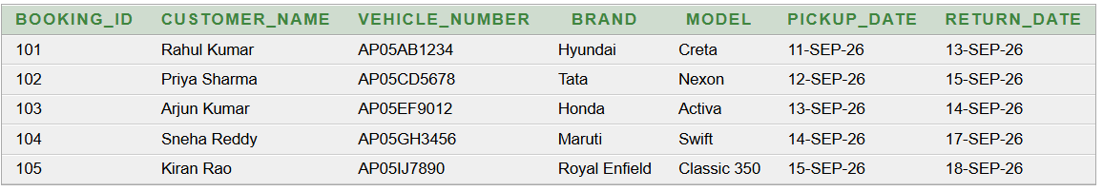
Q12. Display payment details with customer names
SELECT p.Payment_ID,
c.Customer_Name,
p.Amount,
p.Payment_Method,
p.Payment_Date
FROM PAYMENT p
JOIN BOOKING b
ON p.Booking_ID = b.Booking_ID
JOIN CUSTOMER c
ON b.Customer_ID = c.Customer_ID;
Output:
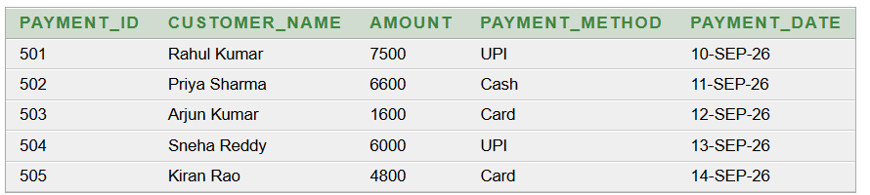
Q13. Find the total payment amount
SELECT SUM(Amount) AS Total_Payment
FROM PAYMENT;
Output:
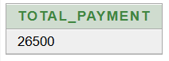
Q14. Find the average rental rate of vehicles
SELECT AVG(Rental_Rate) AS Average_Rental_Rate
FROM VEHICLE;
Output:
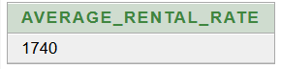
Q15. Display returned vehicles with damage charges
SELECT r.Return_ID,
r.Booking_ID,
r.Return_Date,
r.Fuel_Level,
r.Damage_Charges,
r.Total_Amount
FROM RETURNS r
WHERE r.Damage_Charges > 0;
Output:
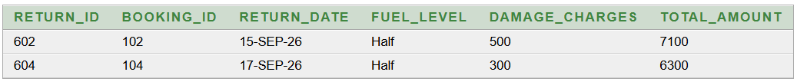
Q16 Display customers who have booked a vehicle
SELECT DISTINCT c.Customer_ID, c.Customer_Name, c.Phone
FROM CUSTOMER c
JOIN BOOKING b
ON c.Customer_ID = b.Customer_ID;

Output:
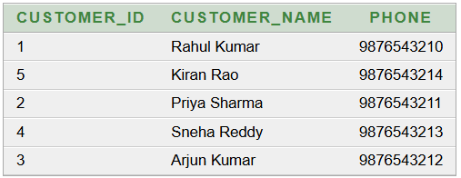
Q17 Display vehicles that are currently rented
SELECT Vehicle_ID, Vehicle_Number, Vehicle_Type, Brand, Model
FROM VEHICLE
WHERE Availability_Status = 'Rented';
Output:
Q18 Display bookings handled by a particular staff member
SELECT b.Booking_ID, b.Booking_Date, b.Pickup_Date, b.Return_Date,
s.Staff_Name
FROM BOOKING b
JOIN STAFF s
ON b.Staff_ID = s.Staff_ID
WHERE s.Staff_Name = 'Ramesh Kumar';
Output:
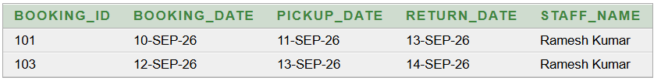
Q19 Display the total payment collected
SELECT SUM(Amount) AS Total_Payment_Collected
FROM PAYMENT;

Output:
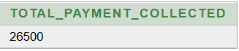
Q20 Display the highest payment amount
SELECT MAX(Amount) AS Highest_Payment
FROM PAYMENT;
Output:
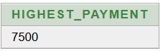
Q21 Display the lowest vehicle rental rate
SELECT MIN(Rental_Rate) AS Lowest_Rental_Rate
FROM VEHICLE;
Output:
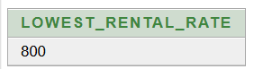
Q22 Display the number of vehicles of each type
SELECT Vehicle_Type, COUNT(*) AS Number_Of_Vehicles
FROM VEHICLE
GROUP BY Vehicle_Type;
Output:
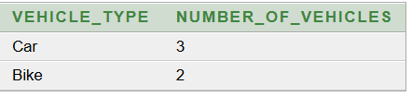
Q23 Display booking details along with payment information
SELECT b.Booking_ID,
b.Booking_Date,
p.Payment_ID,
p.Payment_Date,
p.Amount,
p.Payment_Method
FROM BOOKING b
JOIN PAYMENT p
ON b.Booking_ID = p.Booking_ID;
Output:
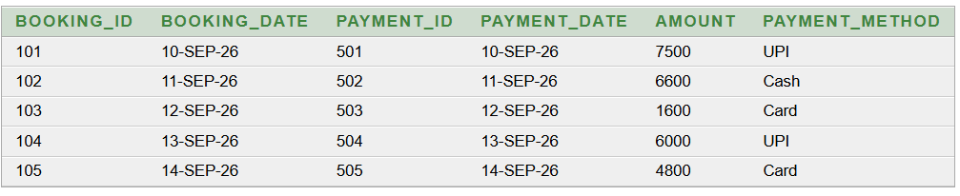Q24 Display return details where damage charges are greater than zero
SELECT Return_ID,
Booking_ID,
Return_Date,
Fuel_Level,
Damage_Charges,
Total_Amount
FROM RETURNS
WHERE Damage_Charges > 0;
Output:
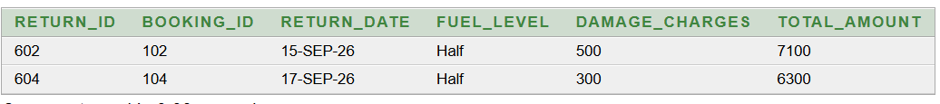
Q25 Display staff members whose salary is greater than 30000
SELECT Staff_ID, Staff_Name, Role, Salary
FROM STAFF
WHERE Salary > 30000;

Output:
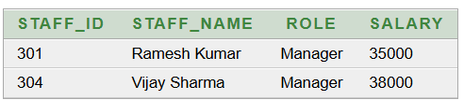
Q26 Display customer details with their booking dates
SELECT c.Customer_ID,
c.Customer_Name,
b.Booking_ID,
b.Booking_Date
FROM CUSTOMER c
JOIN BOOKING b
ON c.Customer_ID = b.Customer_ID;
Output:
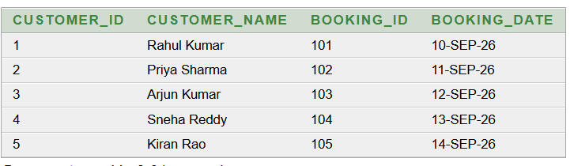
Q27 Display vehicles with rental rate between 1000 and 2500
SELECT Vehicle_ID,
Vehicle_Number,
Vehicle_Type,
Brand,
Model,
Rental_Rate
FROM VEHICLE
WHERE Rental_Rate BETWEEN 1000 AND 2500;

Output:
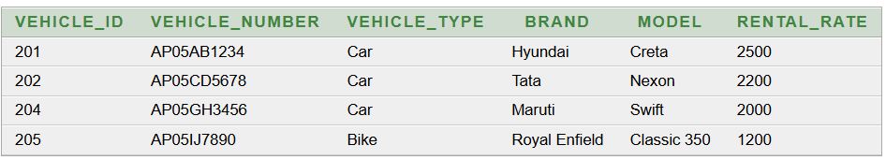
Q28 Display payments made using UPI
SELECT Payment_ID,
Booking_ID,
Payment_Date,
Amount,
Payment_Method
FROM PAYMENT
WHERE Payment_Method = 'UPI';
Output:
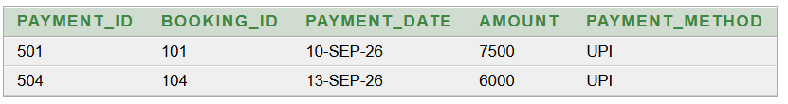
Q29 Display the number of bookings handled by each staff member
SELECT s.Staff_ID,
s.Staff_Name,
COUNT(b.Booking_ID) AS Number_Of_Bookings
FROM STAFF s
LEFT JOIN BOOKING b
ON s.Staff_ID = b.Staff_ID
GROUP BY s.Staff_ID, s.Staff_Name;

Output:
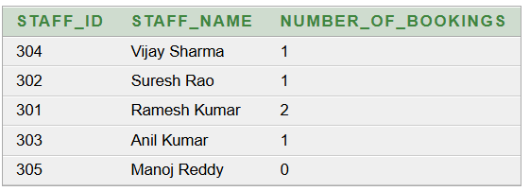

Q30 Display booking details where the return date is after the pickup date
SELECT Booking_ID,
Customer_ID,
Vehicle_ID,
Pickup_Date,
Return_Date
FROM BOOKING
WHERE Return_Date > Pickup_Date;
Output:
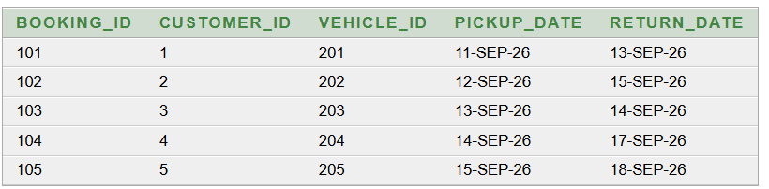

10. CONCLUSION
The Vehicle Rental Management System is a database-based system developed to manage the major activities involved in vehicle rental operations. The system maintains important information about customers, vehicles, staff, bookings, payments, and returns in a structured manner.
The database was designed using appropriate tables, primary keys, foreign keys, constraints, and relationships. Normalization was performed to reduce data redundancy and improve data consistency. The database was implemented using SQL commands for table creation, data insertion, data retrieval, and different types of queries.
The system allows the organization to store customer details, maintain vehicle information, record bookings, manage payment details, and maintain vehicle return information. SQL queries help retrieve useful information from the database, such as available vehicles, booking details, payment information, staff booking details, and return details.
Overall, the Vehicle Rental Management System provides a structured and organized way to manage rental-related data. It reduces manual data handling and makes it easier to store, update, and retrieve information from the database.

11. Future Enhancements
The Vehicle Rental Management System can be further enhanced by adding the following features:
- Online Vehicle Booking
Customers can book vehicles online without visiting the rental office.
- Online Payment
Online payment options can be added to make payment faster and easier.
- Customer Login
Customers can have individual login accounts to view their booking and payment details.
- Automatic Vehicle Availability
The system can automatically update the vehicle status after booking and returning the vehicle.
- Booking Cancellation
Customers can cancel their bookings through the system according to the rental rules.
- Automatic Bill Generation
The system can automatically calculate rental charges, damage charges, and generate the final bill.
- Vehicle Maintenance Records
Maintenance and service details of each vehicle can be stored and monitored.
- Reports and Dashboard
A dashboard can display important information such as total vehicles, available vehicles, bookings, payments, and returns.
- SMS and Email Notifications
Notifications can be sent to customers for booking confirmation, payment confirmation, pickup dates, and return dates.
- Mobile Application
A mobile application can be developed so that customers and staff can access the rental system easily from their smartphones.

REFERENCES
1. Korth, H. F., Silberschatz, A., and Sudarshan, S., Database System Concepts, McGraw Hill.
2. Elmasri, R. and Navathe, S. B., Fundamentals of Database Systems, Pearson.

